**SCREENPRINT OF WINDOWS**

Menubar

Title bar

File/Folder list window

System menu

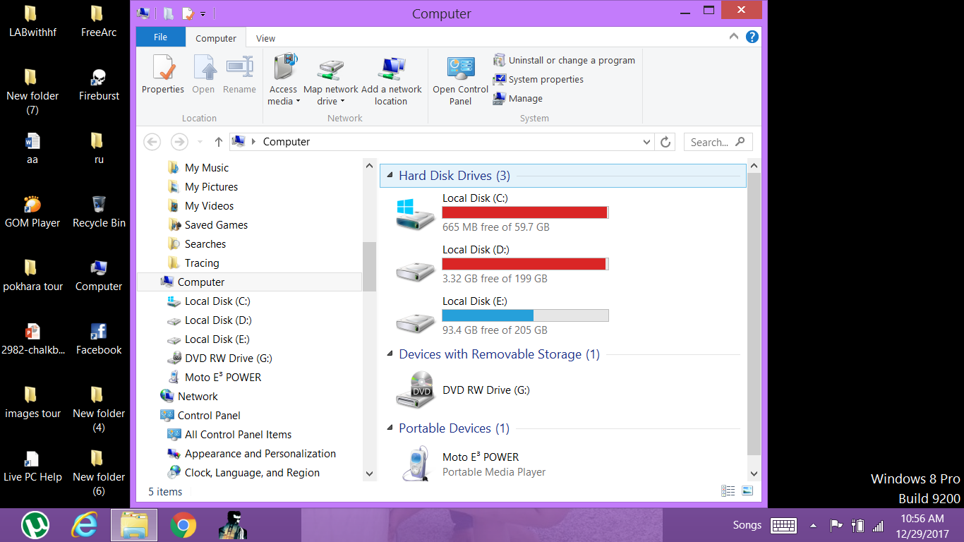

Root Directory

Scroll bar (vertical)

Address bar